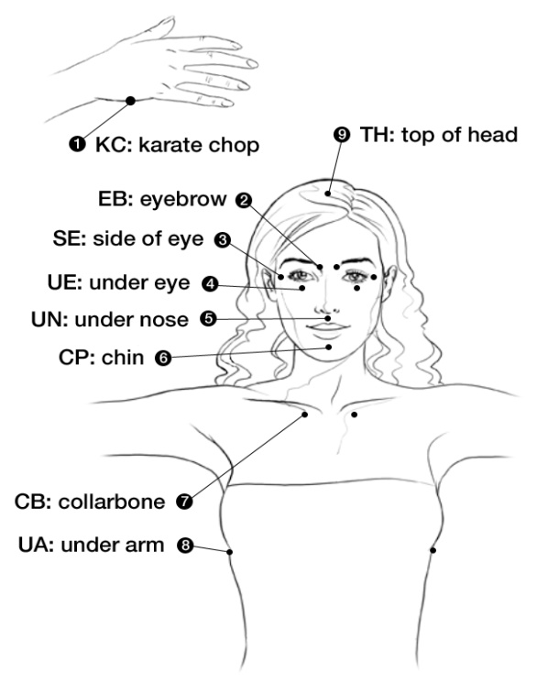

**How to Tap**

1. Assess the level of the emotion and body sensations you are feeling on a scale of 1-10 (10=maximum intensity). Begin with tapping the Karate chop point and saying your set up statement three times- “Even though ……………., I deeply and completely love and accept myself.” Eg, even though I’m feeling completely frustrated and angry with myself because I can’t lose weight, I deeply and completely accept myself… or ‘Even though I have this throbbing headache, I deeply and completely accept myself and it’s safe to let this go. ( with kids “even though I’m…….I’m a really cool kid/I’m loved)
2. Then continue with reminder statements or as though you’re telling someone else your story, tapping the other points on your face and body Eg, this headache is pounding behind my eye, I feel it in my neck and shoulders, I feel helpless…. You can also use the statements I’m safe, I can let this go. It can be used for any stressful situation, even insomnia.
3. After each cycle of tapping, do the “peace process”- grab hold of your wrist, close your eyes and imagine yourself in a calm and peaceful place, a place you feel happy. When you feel relaxed and peaceful, say the word ‘peace’. This will become an anchor to re-set the body to a relaxed feeling no matter what memories/sensations are triggered.
4. Re-assess the level of intensity you are experiencing on a scale of 1-10. If no reduction, keep tapping, and notice if there are other statements, events, memories or beliefs connected to this and tap on those. Alternatively you can tap on universal phrases such as letting go all pain, all sadness, all anger, all fear, all feelings of hopelessness and helplessness, feeling out of control, feelings blame, guilt, grief, loneliness, abandonment, shame, trauma, embarrassment, rejection and numbness with regular reminders that it’s safe to let them go. Keep tapping until you reach a level 0 or for as long as you can.

*EFT always aims at negative emotions and sensations so your set up and reminder statements should reflect this- this is the opposite of positive affirmations. By neutralising the negative effects of beliefs/memories/feelings, we can move on to positive intentions later.

Continue tapping these points in a cycle using different emotions, events and beliefs that you become aware of and as your stress levels reduce, (assess the level of intensity after each round) you can gradually make the statements more and more positive.. Eg I feel so angry: “Maybe one day I’ll be ready to let this go. . I’d like to believe I could let it go….I’m ready to let go of my anger, … Ideally, you should be able to reduce the intensity of emotion to 0 or a level 1 or 2 at the end of your tapping session but if you’re short on time, even one round will help you feel calmer.

*Once the distress has gone, you can then tap a round of positive affirmations or goals. Eg I’m ready to remember what its like to laugh, Some days I feel so relaxed and accepting…. I’m ready to be happy …I’m ready to feel confident…I’m ready to feel excited about feeling and looking fantastic…” Spending a moment to imagine yourself looking, feeling and being confident in the future will boost your mood.

You can tap in the mornings if you’re expecting a difficult day: tap in the shower, take some time out and tap on the toilet or tap discreetly by rubbing the points. Even just holding the karate chop point or just holding the peace point will all have a noticeable effect if you acknowledge silently to yourself what you’re feeling, that you are safe and ready to let it go.

Chrysalis Wellbeing

0430 322711

www.chrysaliswellbeing.com.au

Emotional Freedom Technique: EFT Tapping Points

How does it work?

EFT combines  tapping acupressure points (used in eastern medicine for over 2,00 years) with cognitive behaviour therapy and exposure therapy and is an incredibly powerful technique for fast and effective change. Clinical studies have shown that stimulating acupressure points reduces the release of stress hormones.

I regularly work with people who have experienced trauma, sexual abuse, birth trauma or who are living with anxiety or depression. EFT has proven to be the most effective tool I have experienced in 22 years as a therapist. Not only does it clear current issues, it is extremely effective with the guidance of a skilled therapist in helping re-set painful memories and chronic tension and pain. If you’re not seeing immediate results or for trauma and long term stress and tension, a session with an EFT practitioner can short cut weeks of tapping on your own. Children love using EFT and I use it with my own children and teach it to kids in schools as a way of coping with stress, insomnia, pain, insomnia and low self esteem. It is perfect for helping to settle little ones at bedtime and easing the trauma of cuts and bruises…simply tap on the points for them or teach them how to tap.-often words are not so important with kids, but just saying something like…that really hurts….your safe now, I love you… is enough.

** For a free download of the 60 page EFT mini Manual go to <http://www.eftuniverse.com/>

I also recommend Nick Ortner’s best selling book The Tapping Solution.

If your have benefitted from your experience,

Please like me on facebook.

Clinical Trial Results:

The outcomes of over 20 clinical trials are available at www.eftuniverse.com

A randomized controlled trial to study how an hour-long tapping session would impact the stress levels of 83 subjects found that levels of the stress hormone cortisol was reduced on average by 24% after a 1 hour tapping session, compared to traditional talk therapy which showed no change in cortisol levels (Church, D., Yount, G., & Brooks, A. J. 2012. The effect of Emotional Freedom Techniques (EFT) on stress biochemistry: A randomized controlled trial. *Journal of Nervous and Mental Disease)*. Over 20 clinical trials published in peer-reviewed medical and psychology journals have demonstrated that  EFT is effective for phobias, anxiety, depression, post traumatic stress disorder, pain, addictions, fibromyalgia and exam anxiety.

In a study of 216 healthcare workers who attended a one day workshop on EFT, anxiety and depression  levels dropped by 45% and pain dropped by 68%.  Church, D., & Brooks, A. J. (2010). The effect of a brief EFT (Emotional Freedom Techniques) self-intervention on anxiety, depression, pain and cravings in healthcare workers. Integrative Medicine: A Clinician's Journal, Oct/Nov, 40-44.

A randomized controlled trial of veterans with clinical levels of PTSD symptoms found significant improvements after EFT (Emotional Freedom Techniques). While pain, depression, and anxiety were not the targets of treatment, significant improvements in these conditions were found. Subjects (N = 59) received six sessions of EFT coaching supplementary to primary care. They were assessed using the SA-45, which measures 9 mental health symptom domains, and also has 2 general scales measuring the breadth and depth of psychological distress. Anxiety and depression both reduced significantly, as did the breadth and depth of psychological symptoms. Subjects were followed at 3 and 6 months, revealing significant relationships between PTSD, depression, and anxiety at several assessment points. At follow-up, pain remained significantly lower than pre test. The results of this study are consistent with other reports showing that, as PTSD symptoms are reduced, general mental health improves, and that EFT produces long-term gains for veterans after relatively brief interventions.  Church, D., & Brooks, A. J. (2014). Pain, depression, and anxiety after PTSD. symptom remediation in veterans. Explore: The Journal of Science and Healing (in press).

Best Wishes,

Chrissy Ortner

“Chrysalis Wellbeing & Massage 4 Mums”